**Module Assignment**

**Module 9**

**QMB-6304 Foundations of Business Statistics**



**Preprocessing**

1. Load the file “6304 Module 9 Assignment Data.xlsx” into R. This data set includes several variables on 437 counties in six midwestern states. This will be your master data set
2. Create a single data frame for your analysis. This will be your primary data set. It will meet the following characteristics:
   1. Includes state, popdensity, density.category, percollege, and inmetro variables from the master (N=437) data set.
   2. Be a random sample of n=250, with each state making up 20% of the total sample. For example, 20% of 250 observations will be from the state of Illinois, 20% from Indiana, etc. Use your U number as the random number seed.
   3. The variables state, density.category, and inmetro will be factors.

**#Carolina Aldana Yabur**

**#U25124553**

**#Preprocessing**

**rm(list=ls())**

**setwd("C:/Users/calda/Desktop")**

**library(rio)**

**library(moments)**

**library(car)**

**counties_data= import("6304 Module 9 Assignment Data.xlsx")**

**colnames(counties_data)=tolower(make.names(colnames(counties_data)))**

**subset1= subset(counties_data)**

**subset1$state=as.factor(subset1$state)**

**is.factor(subset1$state)**

**subset1$density.category=as.factor(subset1$density.category)**

**is.factor(subset1$density.category)**

**subset1$inmetro=as.factor(subset1$inmetro)**

**is.factor(subset1$inmetro)**

**subset_state=subset(subset1=="state")**

**subset_popdensity=subset(subset1=="popdensity")**

**subset_density.category=subset(subset1=="density.category")**

**subset_percollege=subset(subset1=="percollege")**

**subset_inmetro=subset(subset1=="inmetro")**

**sample.state=subset_state[sample(1:nrow(subset_state),20,replace=FALSE),]**

**sample.popdensity=subset_popdensity[sample(1:nrow(subset_popdensity),20,replace=FALSE),]**

**sample.density.category=subset_density.category[sample(1:nrow(subset_density.category),20,replace=FALSE),]**

**sample.percollege=subset_percollege[sample(1:nrow(subset_percollege),20,replace=FALSE),]**

**sample.inmetro=subset_inmetro[sample(1:nrow(subset_inmetro),20,replace=FALSE),]**

**mysample=rbind(sample.state,sample.popdensity,sample.density.category, sample.percollege, sample.inmetro)**

**mysample=subset1[sample(1:nrow(subset1),250),]**

**Analysis**

Using your primary data set:

1. Show the results of an str() command.

**#Analysis**

**#Part 1**

**> str(mysample)**

**'data.frame': 250 obs. of 20 variables:**

**$ county : chr "WOOD" "WAYNE" "GALLIA" "BERRIEN" ...**

**$ state : Factor w/ 5 levels "IL","IN","MI",..: 4 1 4 3 2 1 2 5 1 3 ...**

**$ area : num 617 714 469 571 396 ...**

**$ poptotal : num 113269 17241 30954 161378 797159 ...**

**$ popdensity : num 183.5 24.2 66 282.6 2011.8 ...**

**$ density.category : Factor w/ 5 levels "100 to 249","250 to 749",..: 1 5 3 2 4 3 1 3 2 5 ...**

**$ popwhite : num 109303 17141 29831 133259 615039 ...**

**$ popblack : num 1168 9 871 24872 169654 ...**

**$ popamerindian : num 197 31 79 685 1698 ...**

**$ popasian : num 1028 44 136 1487 7579 ...**

**$ popother : num 1573 16 37 1075 3189 ...**

**$ popadults : num 64052 11613 19586 102485 511309 ...**

**$ popchild : num 49217 5628 11368 58893 285850 ...**

**$ percollege : num 29.1 15.7 14.9 23.7 26.7 ...**

**$ percprof : num 8.34 2.76 4.32 6.3 7.69 ...**

**$ percbelowpoverty : num 10.6 14.4 22.5 14.7 12.1 ...**

**$ percchildbelowpovert: num 8.76 19.69 28.46 22.98 18.16 ...**

**$ percadultpoverty : num 12.22 11.62 19.78 11.85 9.76 ...**

**$ percelderlypoverty : num 6.93 14.78 21.77 11 10.73 ...**

**$ inmetro : Factor w/ 2 levels "0","1": 2 1 1 2 2 1 2 1 2 1 ...**

1. Show the results of the table() command on the state variable.

**> #Part 2**

**> table(mysample$state)**

**IL IN MI OH WI**

**71 49 46 45 39**

1. Determine if percollege has an equal variance across all five states. Briefly interpret your results. If you determine there is a difference in variances across the states, discuss where is/are the differences.

**> #Part 3**

**> leveneTest(percollege~state,data = mysample)**

**Levene's Test for Homogeneity of Variance (center = median)**

**Df F value Pr(>F)**

**group 4 0.7676 0.5472**

**245**

Here the p-value is 0.5472, which is greater than the standard significance level 0.05. Therefore, we don’t have enough evidence to reject the null hypothesis that the variance of percollege is equal across all five states.

1. Conduct a one-way analysis of variance with percollege as the dependent variable and state as the independent variable. Plot the results of a Tukey HSD test. Briefly explain the results shown in the plot, stating between which pairs of states do/do not show significant population mean differences in percollege. Make sure factor level names can be clearly and completely read on the appropriate axis of your plot.

**> #Part 4**

**> one.way=aov(percollege~state,data = mysample)**

**> summary(one.way)**

**Df Sum Sq Mean Sq F value Pr(>F)**

**state 4 567 141.78 4.697 0.00114 \*\***

**Residuals 245 7396 30.19**

**---**

**Signif. codes: 0 ‘***’ 0.001 ‘**’ 0.01 ‘*’ 0.05 ‘.’ 0.1 ‘ ’ 1**

**> TukeyHSD(one.way)**

**Tukey multiple comparisons of means**

**95% family-wise confidence level**

**Fit: aov(formula = percollege ~ state, data = mysample)**

**$state**

**diff lwr upr p adj**

**IN-IL -2.86384159 -5.6681404 -0.05954281 0.0426846**

**MI-IL -0.03343858 -2.8913299 2.82445278 0.9999998**

**OH-IL -3.03230209 -5.9093987 -0.15520553 0.0332131**

**WI-IL 0.57870316 -2.4308065 3.58821281 0.9843735**

**MI-IN 2.83040301 -0.2694830 5.93028900 0.0918720**

**OH-IN -0.16846050 -3.2860613 2.94914030 0.9998901**

**WI-IN 3.44254475 0.2023444 6.68274512 0.0310724**

**OH-MI -2.99886351 -6.1647577 0.16703069 0.0728847**

**WI-MI 0.61214174 -2.6745511 3.89883457 0.9861365**

**WI-OH 3.61100525 0.3075992 6.91441128 0.0243189**

**> Hs.out=TukeyHSD(one.way)**

**> Hs.out**

**Tukey multiple comparisons of means**

**95% family-wise confidence level**

**Fit: aov(formula = percollege ~ state, data = mysample)**

**$state**

**diff lwr upr p adj**

**IN-IL -2.86384159 -5.6681404 -0.05954281 0.0426846**

**MI-IL -0.03343858 -2.8913299 2.82445278 0.9999998**

**OH-IL -3.03230209 -5.9093987 -0.15520553 0.0332131**

**WI-IL 0.57870316 -2.4308065 3.58821281 0.9843735**

**MI-IN 2.83040301 -0.2694830 5.93028900 0.0918720**

**OH-IN -0.16846050 -3.2860613 2.94914030 0.9998901**

**WI-IN 3.44254475 0.2023444 6.68274512 0.0310724**

**OH-MI -2.99886351 -6.1647577 0.16703069 0.0728847**

**WI-MI 0.61214174 -2.6745511 3.89883457 0.9861365**

**WI-OH 3.61100525 0.3075992 6.91441128 0.0243189**

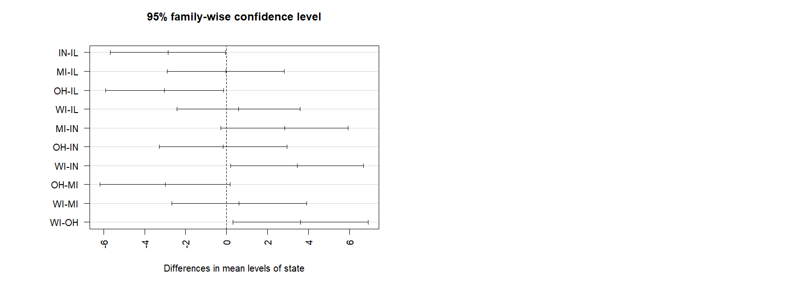

**par(mar=c(5.1,8,4.1,2.1))**

**plot(Hs.out,las=2)**

**par(mar=c(5.1, 4.1, 4.1, 2.1))**

From the plot we can see the confidence intervals that cross the vertical zero line, and we can conclude that there is no statistically significant difference in means between MI-IL, WI-IL, MI-IN, OH-IN, OH-MI, and WI-MI at the 95% confidence level. Two groups (IN-IL, OH-IL) on the left have significantly lower mean than the two groups (WI-IN, WI-OH) on the right side.

1. Repeat Steps 3 and 4 above using percollege as the dependent variable and density.category as the independent variable. Again, briefly explain your analysis results and make sure category names can be clearly and completely read on the appropriate axis of your plot.

**> #Part 5**

**> one.way=aov(percollege~density.category,data = mysample)**

**> summary(one.way)**

**Df Sum Sq Mean Sq F value Pr(>F)**

**density.category 4 2465 616.2 27.46 <2e-16 \*\*\***

**Residuals 245 5498 22.4**

**---**

**Signif. codes: 0 ‘***’ 0.001 ‘**’ 0.01 ‘*’ 0.05 ‘.’ 0.1 ‘ ’ 1**

**> TukeyHSD(one.way)**

**Tukey multiple comparisons of means**

**95% family-wise confidence level**

**Fit: aov(formula = percollege ~ density.category, data = mysample)**

**$density.category**

**diff lwr upr p adj**

**250 to 749-100 to 249 1.1061184 -2.114261 4.326498 0.8793937**

**50 to 99-100 to 249 -4.9623349 -7.411306 -2.513364 0.0000007**

**750 and Above-100 to 249 9.8464195 3.702328 15.990511 0.0001536**

**Below 50-100 to 249 -5.3376196 -7.707754 -2.967485 0.0000000**

**50 to 99-250 to 749 -6.0684533 -9.011963 -3.124944 0.0000004**

**750 and Above-250 to 749 8.7403011 2.382892 15.097710 0.0018409**

**Below 50-250 to 749 -6.4437379 -9.321989 -3.565487 0.0000000**

**750 and Above-50 to 99 14.8087544 8.805150 20.812359 0.0000000**

**Below 50-50 to 99 -0.3752846 -2.352896 1.602326 0.9851281**

**Below 50-750 and Above -15.1840390 -21.155919 -9.212159 0.0000000**

**> Hs.out=TukeyHSD(one.way)**

**> Hs.out**

**Tukey multiple comparisons of means**

**95% family-wise confidence level**

**Fit: aov(formula = percollege ~ density.category, data = mysample)**

**$density.category**

**diff lwr upr p adj**

**250 to 749-100 to 249 1.1061184 -2.114261 4.326498 0.8793937**

**50 to 99-100 to 249 -4.9623349 -7.411306 -2.513364 0.0000007**

**750 and Above-100 to 249 9.8464195 3.702328 15.990511 0.0001536**

**Below 50-100 to 249 -5.3376196 -7.707754 -2.967485 0.0000000**

**50 to 99-250 to 749 -6.0684533 -9.011963 -3.124944 0.0000004**

**750 and Above-250 to 749 8.7403011 2.382892 15.097710 0.0018409**

**Below 50-250 to 749 -6.4437379 -9.321989 -3.565487 0.0000000**

**750 and Above-50 to 99 14.8087544 8.805150 20.812359 0.0000000**

**Below 50-50 to 99 -0.3752846 -2.352896 1.602326 0.9851281**

**Below 50-750 and Above -15.1840390 -21.155919 -9.212159 0.0000000**

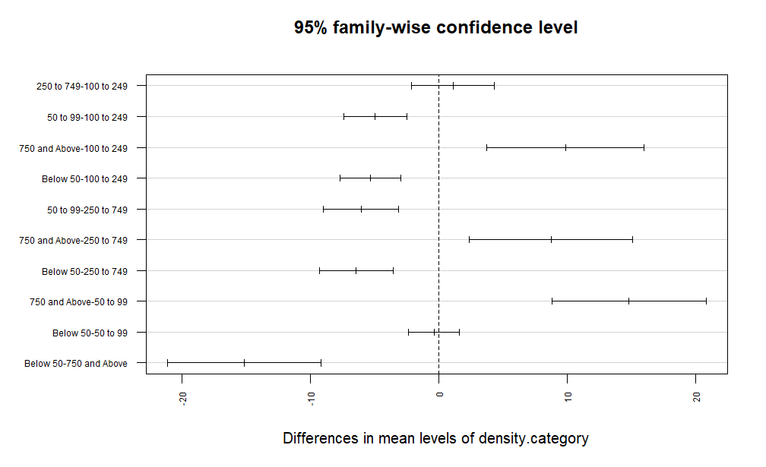

**par(mar=c(5.1,8,4.1,2.1))**

**plot(Hs.out,las=2, cex.axis=.6)**

**par(mar=c(5.1, 4.1, 4.1, 2.1))**

From the plot we can see the confidence intervals that cross the vertical zero line, and we can conclude that there is no statistically significant difference in means between 250 to 749-100 to 249, and Below 50-50 to 99 at the 95% confidence level. Five groups on the left have significantly lower mean than the three groups on the right side.

1. Conduct a two-way ANOVA using percollege as the dependent variable and both state and inmetro as the independent variables. Plot the results of a Tukey HSD test to show whether/where there are differences in percollege. Briefly explain the results shown in the plot, stating if state and inmetro together appear to show significant mean differences in percollege. Make sure the names of levels of independent variables can be clearly and completely read on the appropriate axis of your plot. Be sure to include and interpret an appropriate test for equality of variances.

**> #Part 6**

**> two.way=aov(percollege~state+inmetro,data = mysample)**

**> summary(two.way)**

**Df Sum Sq Mean Sq F value Pr(>F)**

**state 4 567 141.8 6.052 0.000117 \*\*\***

**inmetro 1 1680 1679.6 71.695 2.37e-15 \*\*\***

**Residuals 244 5716 23.4**

**---**

**Signif. codes: 0 ‘***’ 0.001 ‘**’ 0.01 ‘*’ 0.05 ‘.’ 0.1 ‘ ’ 1**

**> TukeyHSD(two.way)**

**Tukey multiple comparisons of means**

**95% family-wise confidence level**

**Fit: aov(formula = percollege ~ state + inmetro, data = mysample)**

**$state**

**diff lwr upr p adj**

**IN-IL -2.86384159 -5.33435051 -0.3933327 0.0139893**

**MI-IL -0.03343858 -2.55116106 2.4842839 0.9999996**

**OH-IL -3.03230209 -5.56694382 -0.4976604 0.0101052**

**WI-IL 0.57870316 -2.07259079 3.2299971 0.9750027**

**MI-IN 2.83040301 0.09949002 5.5613160 0.0380297**

**OH-IN -0.16846050 -2.91497975 2.5780587 0.9998180**

**WI-IN 3.44254475 0.58801871 6.2970708 0.0092704**

**OH-MI -2.99886351 -5.78792790 -0.2097991 0.0280838**

**WI-MI 0.61214174 -2.28334287 3.5076263 0.9777728**

**WI-OH 3.61100525 0.70079679 6.5212137 0.0067542**

**$inmetro**

**diff lwr upr p adj**

**1-0 5.4916 4.190151 6.79305 0**

**> Hs.out=TukeyHSD(two.way)**

**> Hs.out**

**Tukey multiple comparisons of means**

**95% family-wise confidence level**

**Fit: aov(formula = percollege ~ state + inmetro, data = mysample)**

**$state**

**diff lwr upr p adj**

**IN-IL -2.86384159 -5.33435051 -0.3933327 0.0139893**

**MI-IL -0.03343858 -2.55116106 2.4842839 0.9999996**

**OH-IL -3.03230209 -5.56694382 -0.4976604 0.0101052**

**WI-IL 0.57870316 -2.07259079 3.2299971 0.9750027**

**MI-IN 2.83040301 0.09949002 5.5613160 0.0380297**

**OH-IN -0.16846050 -2.91497975 2.5780587 0.9998180**

**WI-IN 3.44254475 0.58801871 6.2970708 0.0092704**

**OH-MI -2.99886351 -5.78792790 -0.2097991 0.0280838**

**WI-MI 0.61214174 -2.28334287 3.5076263 0.9777728**

**WI-OH 3.61100525 0.70079679 6.5212137 0.0067542**

**$inmetro**

**diff lwr upr p adj**

**1-0 5.4916 4.190151 6.79305 0**

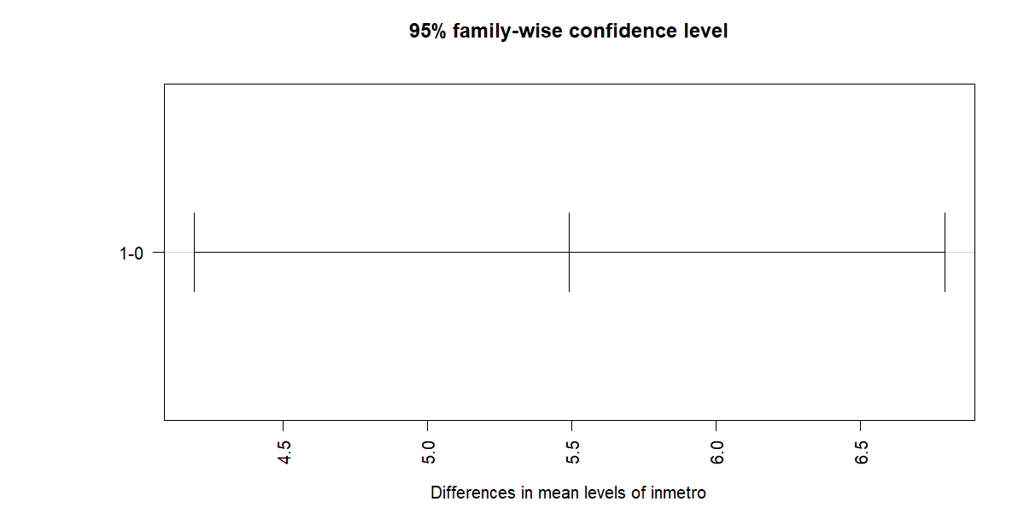

**par(mar=c(5.1,8,4.1,2.1))**

**plot(Hs.out,las=2, cex.axis=.6)**

**par(mar=c(5.1, 4.1, 4.1, 2.1))**

From the plot we can see that the confidence interval does not include zero, suggesting that there is no statistically significant difference in means between percollege and state and inmetro at the 95% confidence level. Therefore, the factor variables inmetro and state do not seem to have a meaningful impact on percollege.

Your deliverable will be a single MS-Word file showing 1) the R script which executes the above instructions and 2) the results of those instructions. The first line of your script file should be a “#” comment line showing your name as it appears in Canvas. Results should be presented in the order in which they are listed here. Deliverable due time will be announced in class and on Canvas. **This is an individual assignment to be completed and submitted by the time stated on Canvas. No collaboration of any sort is allowed on this assignment.**